**01: Mocking and Stubbing**

**CODE** :

ExternalApi :

package com.example;

public interface ExternalApi {

String getData();

}

MyService.java –

package com.example;

public class MyService {

private final ExternalApi externalApi;

public MyService(ExternalApi externalApi) {

this.externalApi = externalApi;

}

public String fetchData() {

return externalApi.getData();

}

}

MyServiceTest –

package com.example;

import org.junit.jupiter.api.Test;

import static org.mockito.Mockito.*;

import static org.junit.jupiter.api.Assertions.*;

public class MyServiceTest {

@Test

public void testExternalApi() {

ExternalApi mockApi = mock(ExternalApi.class);

when(mockApi.getData()).thenReturn("Mock Data");

MyService service = new MyService(mockApi);

String result = service.fetchData();

assertEquals("Mock Data", result);

}

}

ScreenShot -

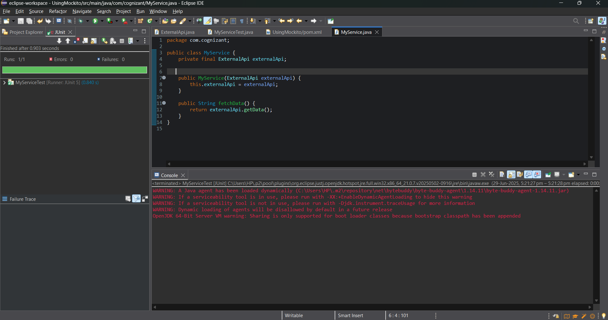

**02 : Verfying Interactions**

**CODE**:

package com.cognizant;

import org.junit.jupiter.api.Test;

import static org.mockito.Mockito.*;

public class TestVerfiyInteraction {

*@Test*

public void testVerifyInteraction() {

ExternalApi mockApi = *mock*(ExternalApi.class);

MyService service = new MyService(mockApi);

service.fetchData();

*verify*(mockApi).getData();

}

}

ScreenShot :

